DYS Partners with Ed Farm to Offer Free Coding Class to Birmingham-Area Students

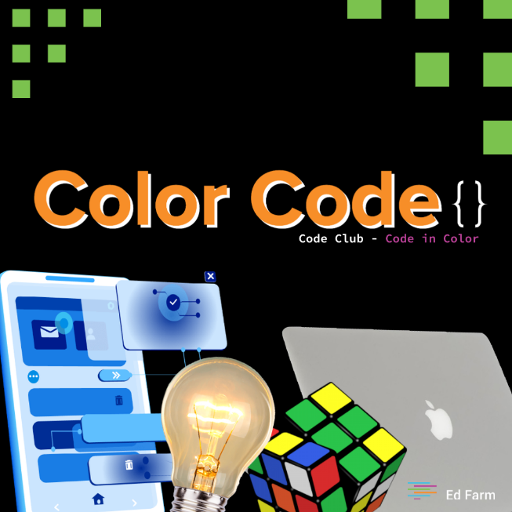
The City of Birmingham Mayor's Office Division of Youth Services (DYS) is proud to partner with Ed Farm to bring a cutting-edge coding experience to Birmingham-area students. On January 27, 2021, students who participate in this FREE Color Coding club will have the opportunity to learn Swift, a powerful and intuitive programming language for Apple's devices (macOS, iOS, watchOS, tvOS) as well as one of the easiest programming languages to learn. Ed Farm has partnered with Apple and adopted their educational curriculum to teach Swift Coding in a creative, cultivating, and inventive approach.
Join our teams as we bring students together through an hour-long coding session. Students can register to learn the basics of the swift coding language on January 27, 2021 beginning at 4:00 p.m. via Zoom.
The class is open to any student in the Birmingham Metro area.

Students will receive further instructions on how to participate once they register.
Click HERE to register.

For more information about the Ed Farm Color Code Club contact DYS at dys@birminghamal.gov or call (205) 320-0879.

